‘ Wargrave Woggle

Forthcoming events
28th September  2nd November | Scout Group Family Day  Annual Village Fireworks
10th November  6th December  December | Remembrance Parade  Scout Autumn Show  Scout Christmas Post

Scout Group Family Day – 28th September 2013
Following on from a very successful “Family Activity Day” last summer, the Leaders are organizing another Family Day at Youlbury Scout Activity Centre near Oxford this September. This is not a camping event but is an opportunity for all, young and old, to spend the day doing some outdoors activities which include archery, go karts, crate stacking, climbing, an adventure course and much more. Activities are planned to start at 09:30 and will run through until early evening when we will finish the day off with a barbeque. The event will close by about 7:30pm. Confirmation of numbers and payment must be made to Nigel Board (npboard@hurstdata.com) by September 16th please.

Annual Village Fireworks –Sat November 2nd.
As is customary, the Scout Group will be running the Annual Village Fireworks again this year. As you know, there are many ways in which you can help us “pull off” this event, ranging from cooking the meat to helping build the bonfire and clearing up after the event. We really do hope that parents from every family can help in some way, and by doing one or two jobs where you can. In addition to this being a major community event, it is the Group’s most important fundraiser too.
Recent Events

Easter Egg Hunt
The Scout Group organized our “annual” Easter Egg Hunt back on a snowy March Saturday afternoon. Yet again, it was a very successful event enjoyed by many of the youngsters in Wargrave. Our thanks go to John and Julie Wheals, Jackie Colvin, Pete Fry and other committee members for their organization of this event.

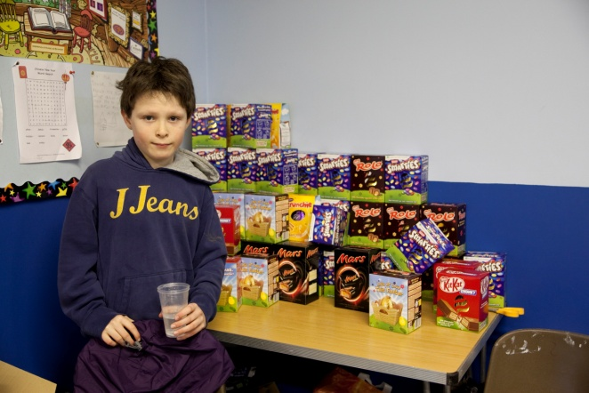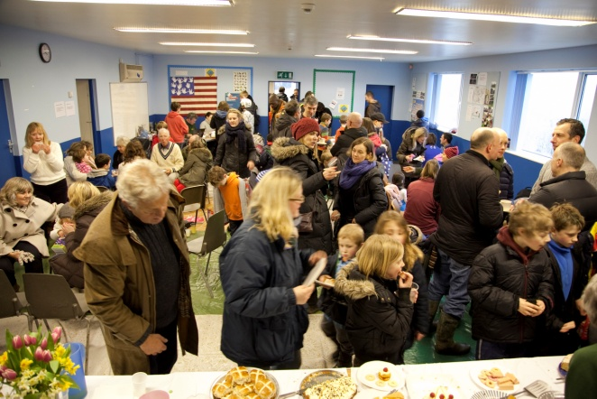

Wargrave Festival 2013 Events
The Scout Group were very pleased to win back the “Shield” for our float entry entitled “Carry on Camping” in the Festival parade.

In addition, we ran a very successful tea tent, serving teas and homemade cakes (donated by many of the Scout troop parents) during the afternoon. The cubs were splendid waiters and many parents helped by serving – thank you to all. In addition, we were very fortunate to have the opportunity for the Beavers to sell locally grown strawberries and raspberries donated by Sheeplands this year. In total, we made a record breaking profit of £925 which will go into the Scout Group funds. Thank you all for helping.

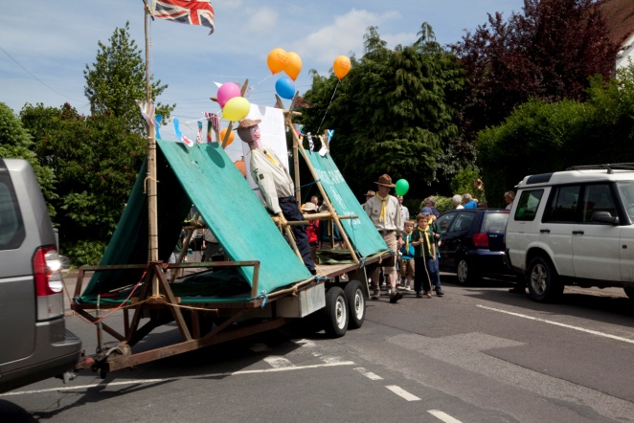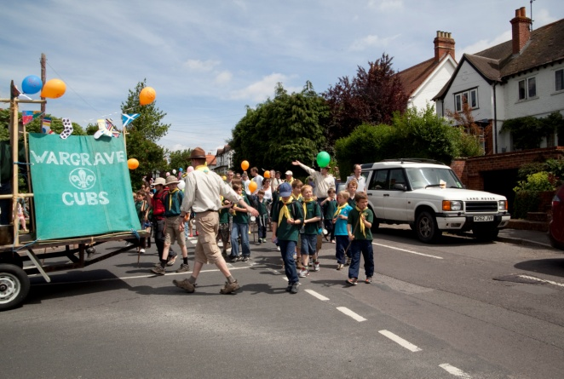
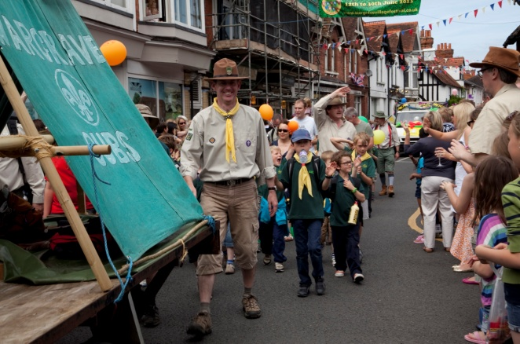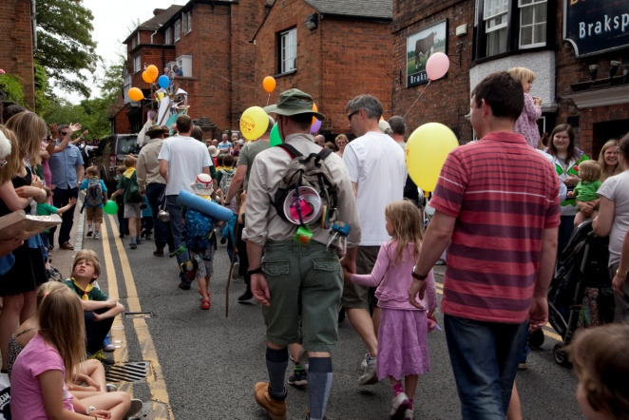

Buddy’s Legacy
Many of you will remember Buddy Rose. When he died he left a donation to the Group and with this the Exec Committee have had a new flag pole built in the HQ, made from oak grown in Windsor Great Park the flag pole has decorations that reflect Buddy's love of nature and his time in the Merchant Navy. In addition, we have also decided to give every member of the Scout Troop (at the time of his death and all of those invested thereafter) a copy of Baden Powell’s “Scouting for Boys” in his memory. In this way we hope to keep the contribution that Buddy made to so many of us very much alive. These have been distributed recently.
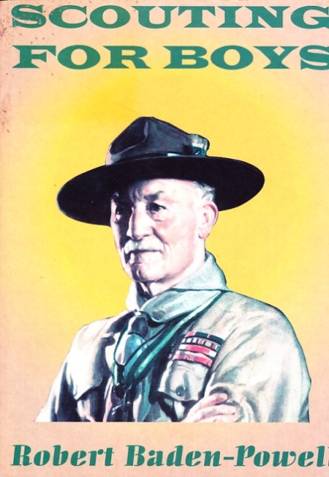
The Group has also installed a bench in Buddy’s memory on the edge of the cricket green, near the car-park on Recreation Road, which many of you may have sat upon over the summer!

Subscriptions
The price of subs is £30 per term. If you pay before September 30th you will get a £2 discount reducing this to £28. Please send all subs to Pennie Withers 20 Langhams Way, Wargrave tel no 940 6037. (Email charlie.pennie@btinternet.com).

Criminal Records Bureau (CRB) Checks, now also known as the Disclosure and Barring Service (DBS)

Although the Group currently operates within the Policy Organisation and Rules of the Scout association with regards to all aspects of its running, including safeguarding and child protection, the Group Executive has agreed the following aim for all sections within the Scout Group in order to promote the safeguarding of all of our children:

The Group requests that at least 1 adult from each family completes a CRB check such that if asked to assist in any activity, both parents and leaders can be reassured that the likelihood of inappropriate adults being in close proximity to any children has been reasonably addressed and the risks minimised.

For those adults wishing to participate in any overnight Scouting activity (e.g. a Family Camp) the Group will strictly uphold the Scout Association requirements that all adult participants must have completed a CRB assessment.

It should be noted that most outdoor activities that are run in the Group can only be safely provided if all adults involved have been assessed for their suitability for working with children. For occasional helpers and parents assisting on a parent rota this can be readily addressed by means of the completion of a CRB check.

It is imperative that parents of a child within the 1st Wargrave Scout Group take an active role in the completion of the CRB form. Forms are available from your LEADER (and will shortly be available on the website) and these should be completed and returned with appropriate ID to your LEADER who will check them and then pass on for processing.

Uniform
Uniform is available from the Scout hut at Addington School in Loddon Bridge Road, Woodley, however you may want to check with Pennie Withers on 940 6037 if there is any second hand available before you buy new. If anyone has any old uniform they would like to donate for selling for Scout funds please leave it in the Wargrave Scout hut in a bag labeled for the attention of Pennie with your name and phone number.

The dark green “1st Wargrave” polo shirts are uniform for Beavers and Cubs and optional for Scouts. They are available from the scout hut for £11, please pay your leader.

Hire of hut
The Scout Hut is available to be hired out to people in the village, eg for birthday parties, at £10/hour (2 hour min). The hut has a fully equipped kitchen, trestle tables, chairs, etc. Contact Abby Luckhurst on 940 3190, for more information (Email: Abby@jamesluckhurst.co.uk)

Committee News
During the past year, Jon and Patricia Black have stepped down from being Cub Scout Leader and Assistant Leader, Neil Reid has retired as an assistant Cub Scout Leader, as has Claire Stacey. Caroline Atkinson has stopped her role as Assistant Scout Leader this summer, and Michelle Williams left earlier on in the year. We thank all of them for the many years they gave to us.

Fiona Keen has now replaced him as Cub Scout Leader of the Pumas and we welcome Christine Walker who has joined Simon and Richard with the Wildcats as an assistant Cub Leader. Welcome also to Sarah Lloyd who is joining Paul Worthington this term to assist him and Ken Burke running the Woodchucks. Any additional volunteers would be most appreciated.

Andy Silby joined the committee back at the beginning of the year, and Mairead Duke, Jackie Colvin and Julie Wheals have left the committee at our AGM in May. Katie Blades is not looking after the hut bookings anymore, however Abby Luckhurst (see details above) has kindly agreed to take over this role. We thank all of these members for their efforts on behalf of the Scout Group, and if anyone would like to join, the Committee would be delighted to hear from you.

After many years of brilliantly looking after the website, Kim Board-Allam has also stepped down from her role and is currently working with Kieron Edwards who has kindly stepped up to take over from this role, many thanks to you both.

Chair | Helen Vonka | 940 1139
Secretary | Wendy Dowling | 940 6460
Treasurer | Janet Moseley | 940 3254
Subscriptions/2nd hand uniform | Pennie Withers | 940 6037
Quartermaster | Bill Bookless | 940 4441
Scout Hut Hire | Abby Luckhurst | 940 3190
Exec Member | Karen Bacon | 940 1893
Exec Member | Lesley Thomas | 934 2810
Exec Member | Andy Silby | 327 6744
Exec Member | Bruce Glasby | 940 1504
Group Scout Leader | Peter Fry | 940 1134
Scout Leader | Nigel Board | 934 4390
Cub Scout Leader - Pumas (Tues) | Fiona Keen | 01491 413184
Cub Scout Leader - Wildcats (Thurs) | Simon Smith | 940 6110
Beaver Scout Leader - Lumberjacks | Jane Austen | 940 3038
Beaver Scout Leader - Woodchucks | Paul Worthington | 940 6599

l
Helen Vonka
On behalf of 1st Wargrave Scout Executive committee

